Acceptance test
Progress bar
Acceptance criteria
User sees the program is active while it’s running the BLAST algorithm
User opens up the main screen
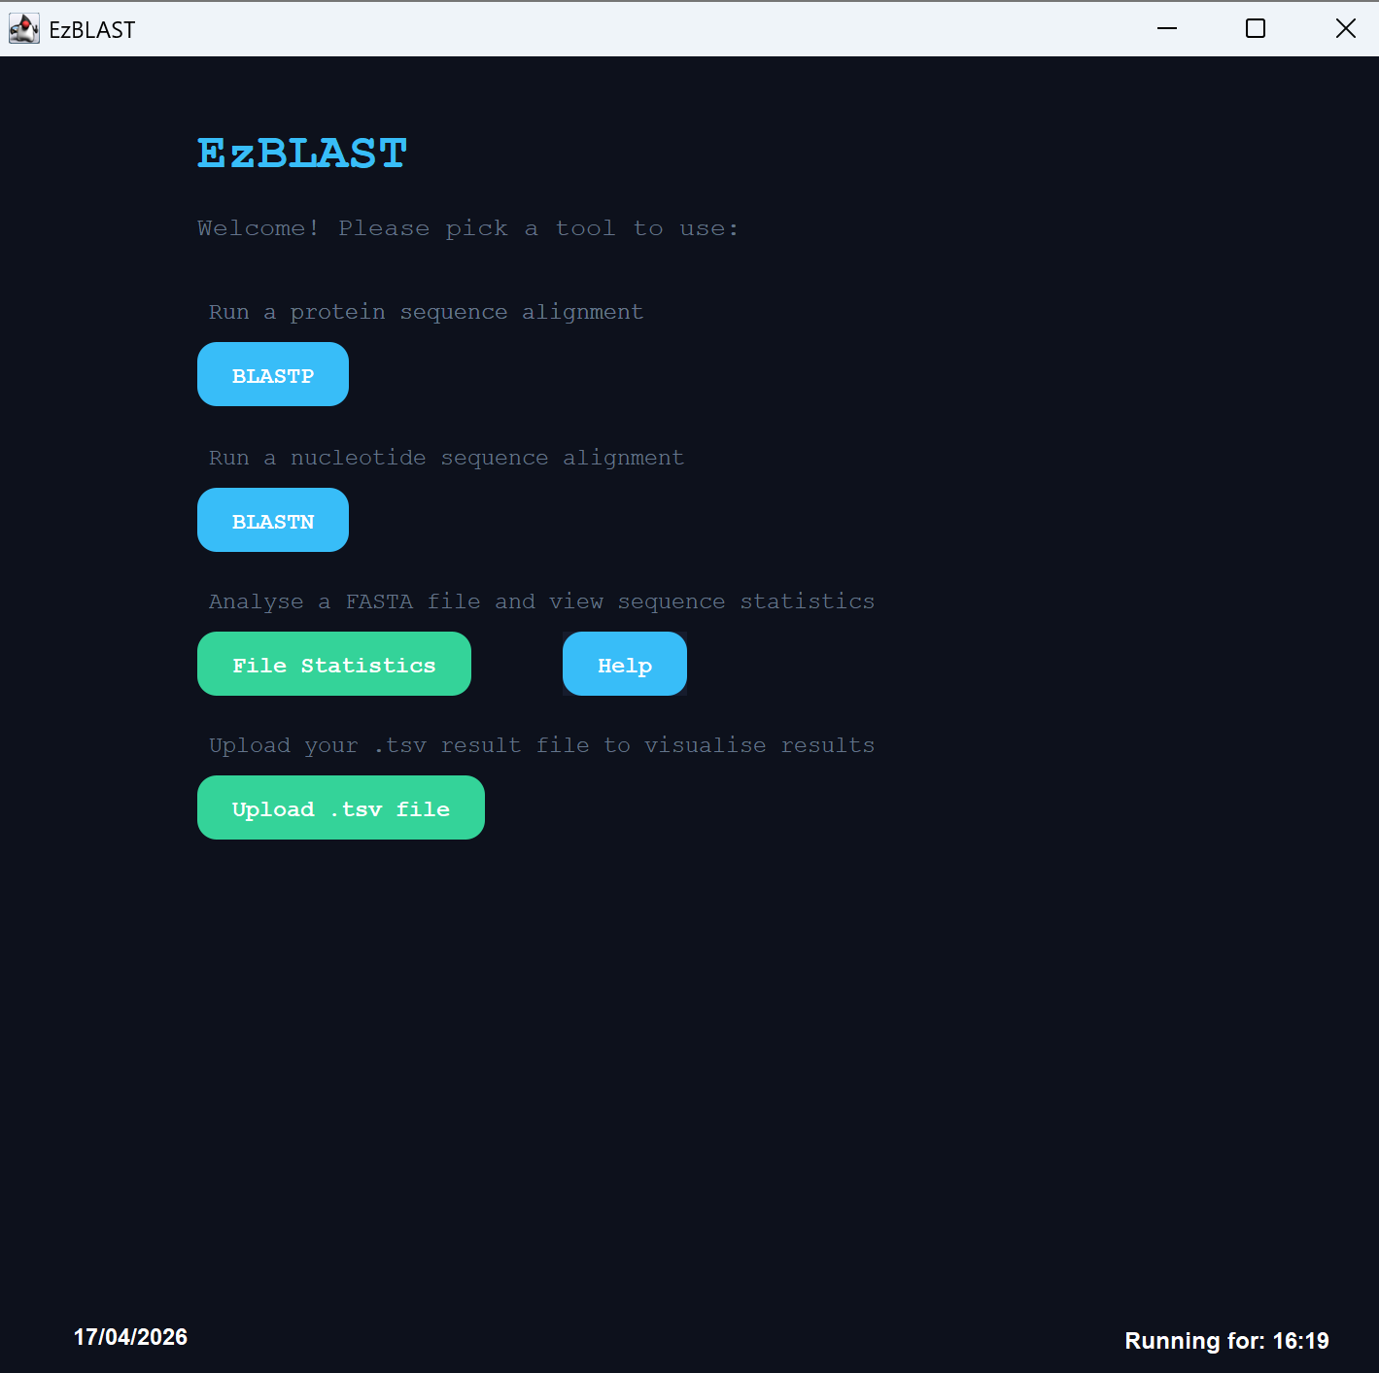
The user has selected BLASTP
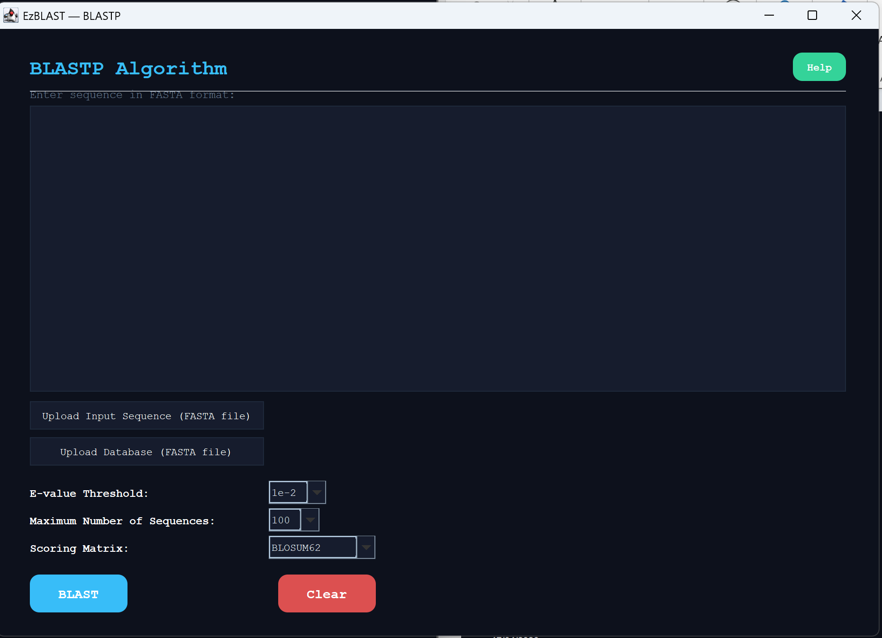
The user uploads their file
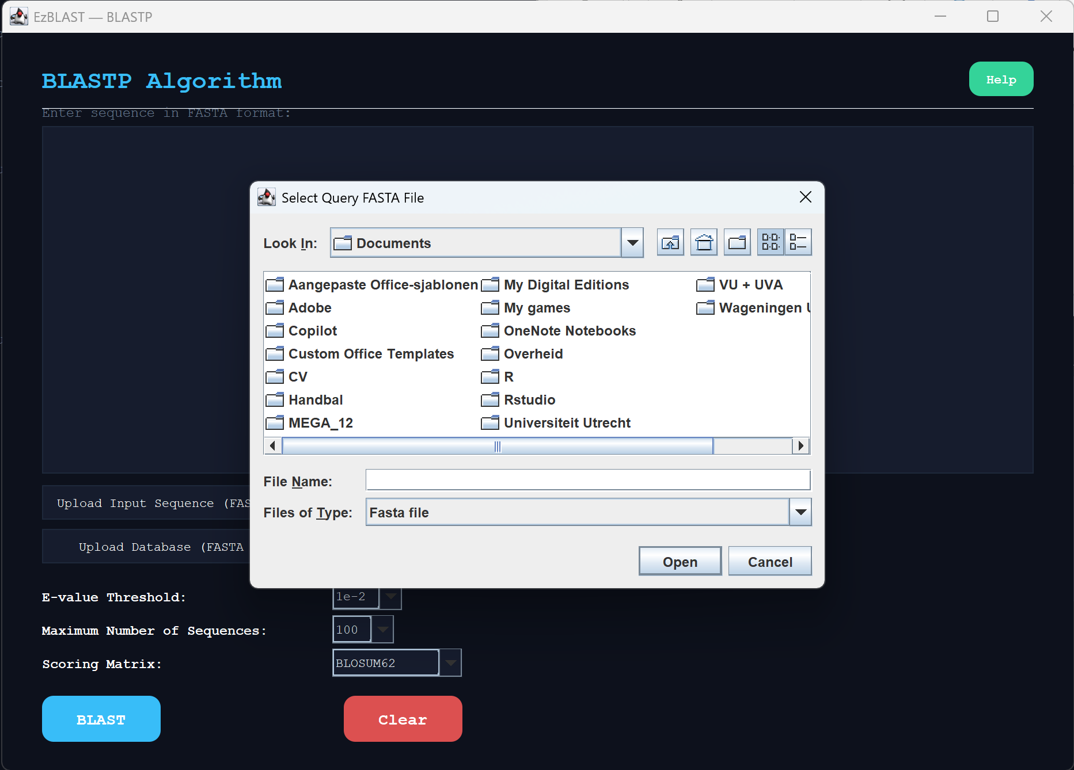
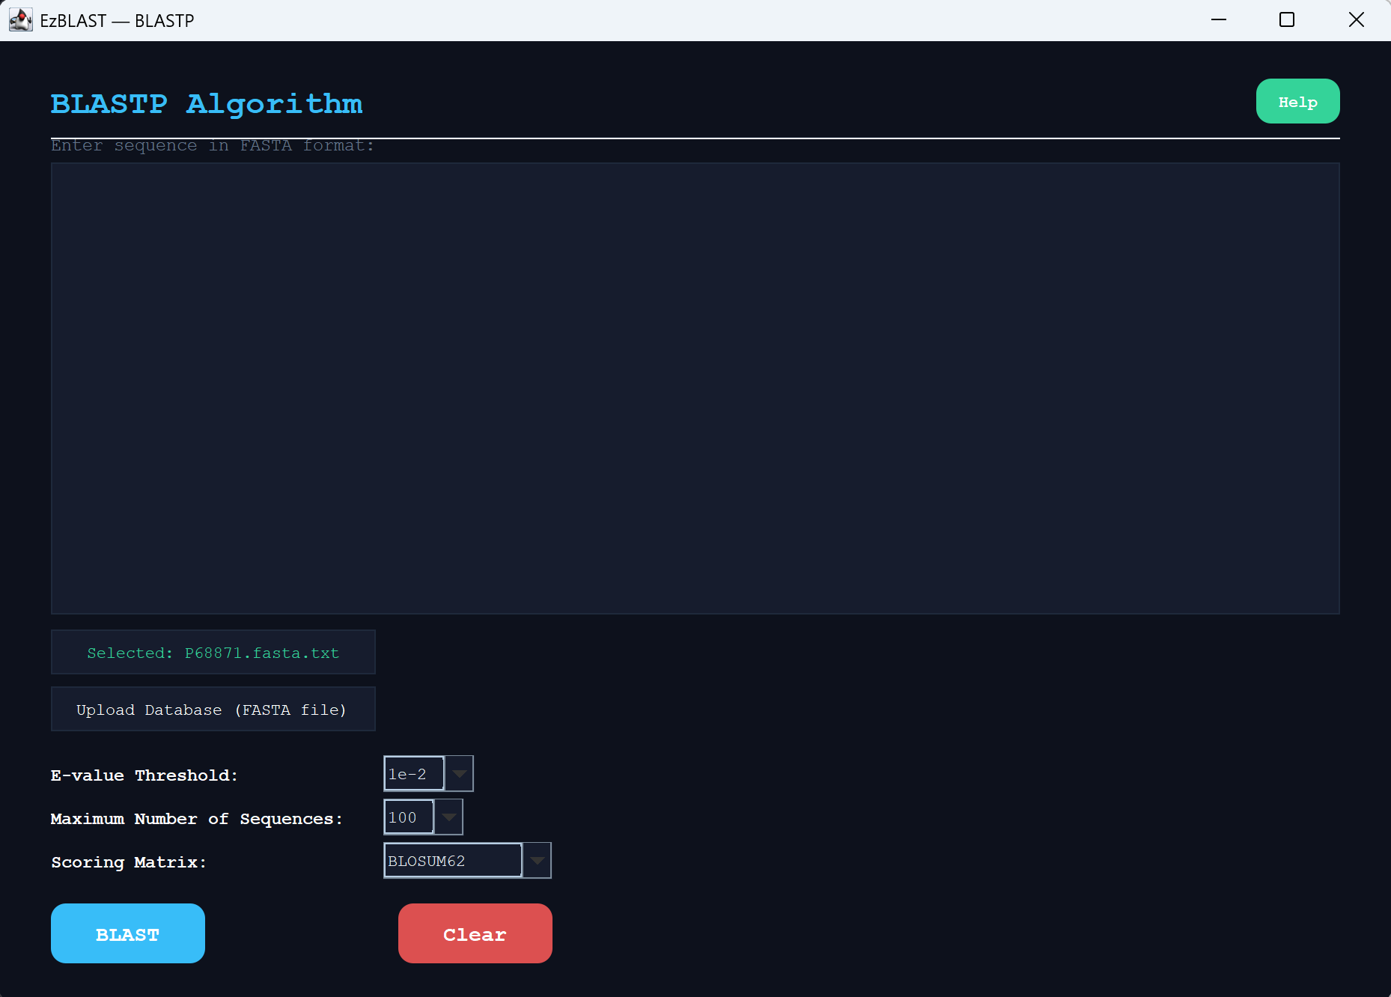
The user runs BLASTP
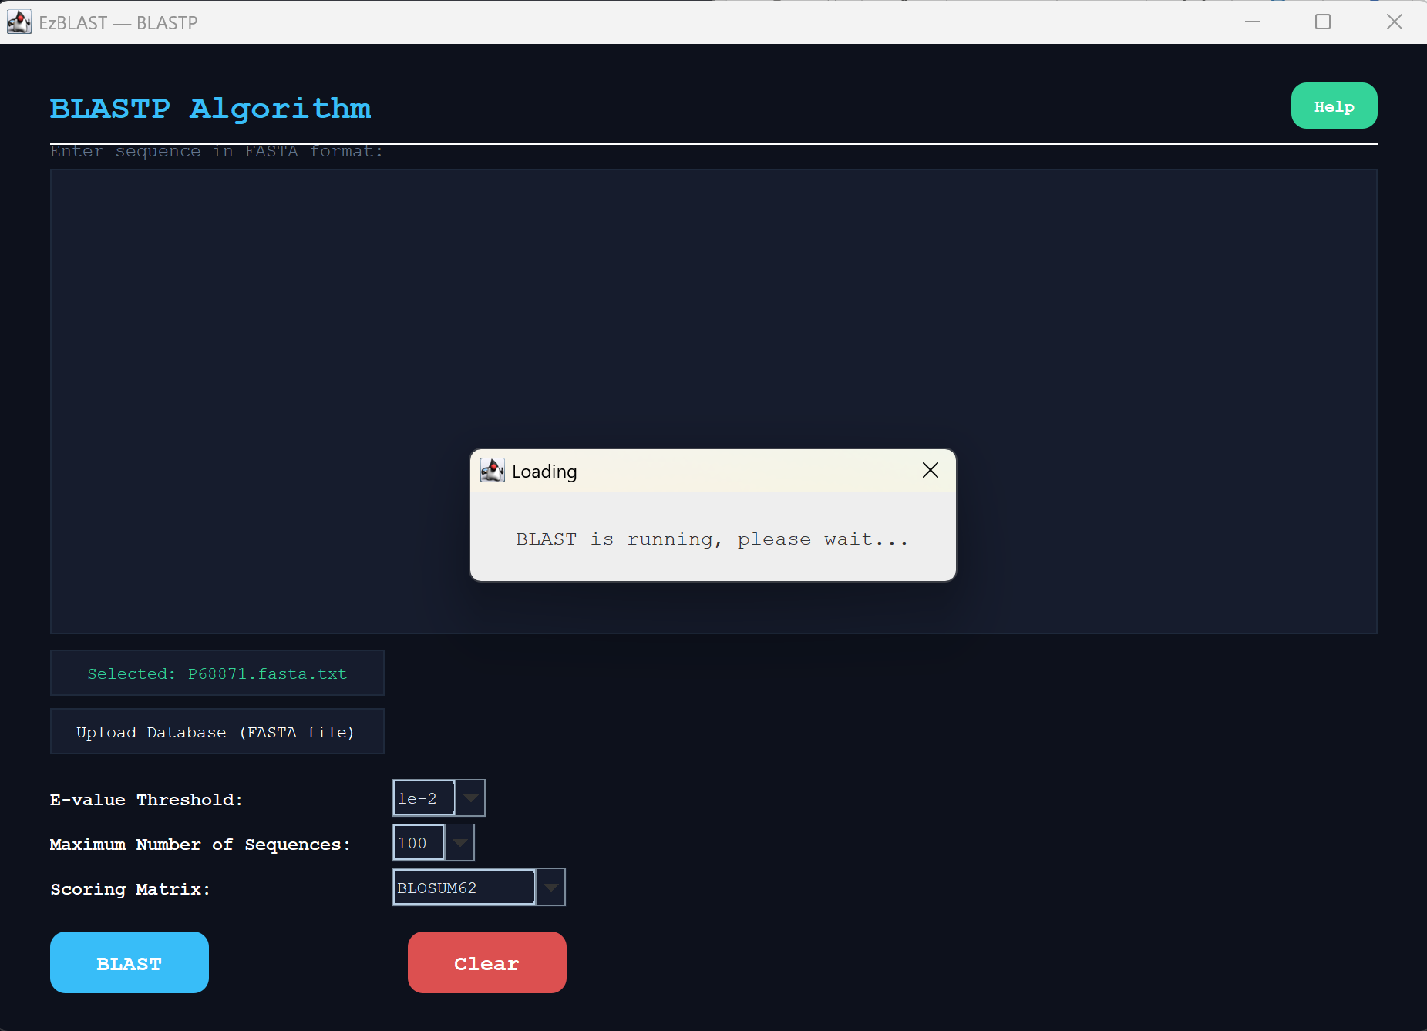
And the algorithm was successful
